THE 1960 BABY BIRDS FLY!

AN ANALYSIS OF THEIR CONTRIBUTIONS
TO THE 1960 ORIOLES AND BEYOND

BY STEVE KREVISKY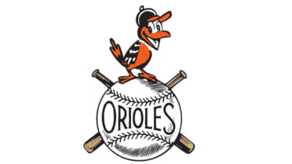

AND ELLIOT HINES

FOR THE 2022 SABR CONVENTION

BALTIMORE, MD
AUGUST 2022 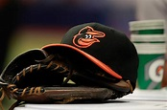
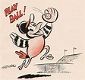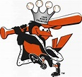

Introduction: Steve K

THE 4 BABY BIRDS WERE:
- MILT PAPPAS
- CHUCK ESTRADA
- STEVE BARBER
- JACK FISHER
WHILE THEY WEREN’T ALL ROOKIES IN 1960, THEY PITCHED AS A QUARTET FOR THE FIRST TIME IN 1960.

WE WILL EXAMINE THEIR 1960 ACHIEVEMENTS, AS WELL AS HOW THEY PERFORMED IN SUBSEQUENT SEASONS.

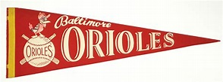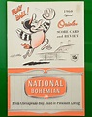

STEVE K:
CHUCK ESTRADA BROKE IN WITH A BANG IN 1960! HE PACED THE AL WITH 18 WINS, WAS SELECTED TO THE AL ALL-STAR GAME, AND WAS CHOSEN AS THE SPORTING NEWS PITCHER OF THE YEAR IN THE AL, WITH A 3.58 ERA.

HE WAS A 15 GAME WINNER IN 1961, BUT HIS WILDNESS DERAILED HIS CAREER, ALONG WITH ELBOW PROBLEMS.

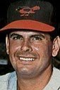

ELLIOT HINES ( THE BIG E )
ON STEVE BARBER:
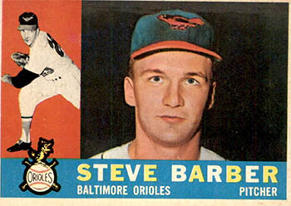
STEVE BARBER
HE DEBUTED IN 1960, WINNING 10 AND LOSING 7, WITH A 3.22 ERA. HE WAS KNOWN FOR THROWING HARD, AND WOULD WIN 18 GAMES IN 1961, LEADING THE AL IN SHO. IN 1963, HE WOULD WIN 20 GAMES, FINALLY MAKING THE AL ALL-STAR TEAM.

MILT PAPPAS ( BIG E):
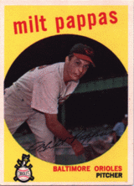
HE DEBUTED IN 1957. IN 1960,HE WENT 15-11, WITH A 3.37 ERA. HE ALSO THREW A LIVELY FASTBALL, AND HAD THE BEST CAREER OF THE 4 BABY BIRDS. HE MADE THE ALL STAR TEAM IN 1962 AND 1965, ALONG WITH WINNING 15+ GAMES IN 7 DIFFERENT SEASONS.
PEOPLE REMEMBER HIM FOR BEING TRADED FOR FRANK ROBINSON IN 1965, BUT MILT DID WIN 209 CAREER GAMES, ALTHOUGH HE NEVER WON 20 IN A SEASON. MORE ON HIM LATER!

STEVE K AGAIN:
JACK FISHER WAS THE 4TH BABY BIRD, GOING 12-11, WITH A 3.41 ERA. HE HAD PITCHED FOR THE O’S IN 1959, BUT 1960 WAS THE ONLY YEAR THAT HE WAS OVER .500 IN HIS CAREER.
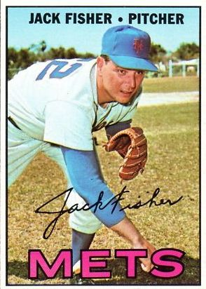
HE IS REMEMBERED FOR HURLING FOR THE BAD METS TEAMS, ALONG WITH SURRENDERING TED WILLIAMS’ LAST CAREER HOMER, IN FENWAY PARK, AND ROGER MARIS’ 60TH HOME RUN IN 1961. HE HAD THE LEAST SUCCESSFUL CAREER OF THESE 4.

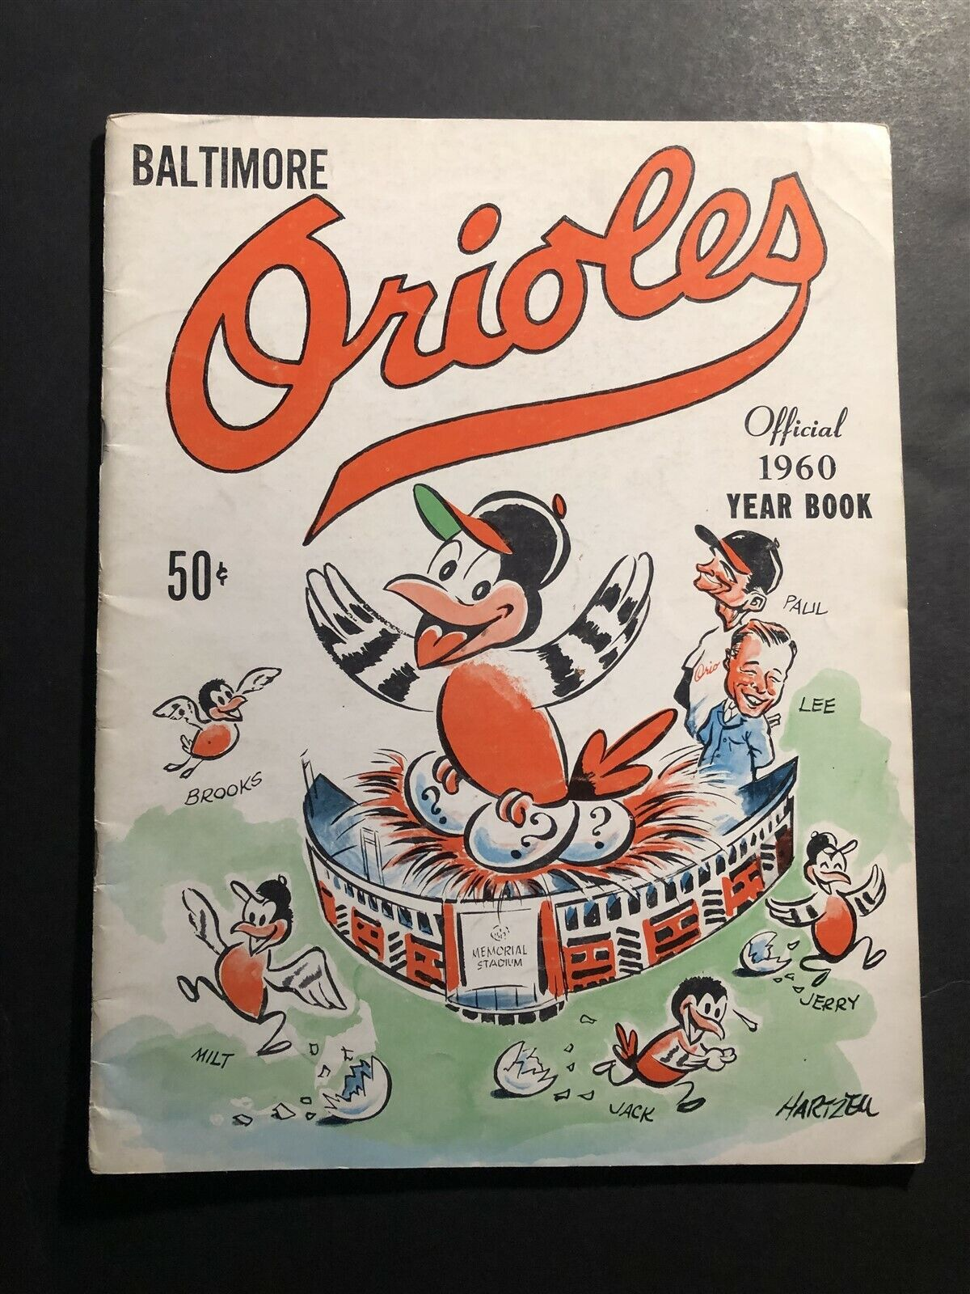
SUMMARY CHART FOR BABY BIRDS 1960: (STEVE K)

PITCHER W L ERA CG ERA+ WAR
ESTRADA 18-11 3.58 12 107 2.7
BARBER 10-7 3.22 6 119 2.1
PAPPAS 15-11 3.37 11 114 3.3
FISHER 12-11 3.41 8 112 1.8

THE 1960 SEASON:
LED BY MANAGER PAUL RICHARDS, THE O’S FINALLY HAD A WINNING RECORD, GOING 89-65, AND DUKING IT OUT WITH THE YANKEES FOR THE AL PENNANT. THE YANKS WERE NECK AND NECK WITH THE BIRDS ALL SEASON, UNTIL THE YANKS SWEPT BALTIMORE IN A 4 GAME SET, BEGINNING IN MID SEPTEMBER. THE FOUNDATION AND LEGACY WAS BEING CREATED FOR THE O’S FUTURE SUCCESS LATER IN THE DECADE.

THE BIRDS FEATURED 4 ALL-STARS, NAMELY, ESTRADA, GENTILE, HANSEN AND ROBINSON. HANSEN WAS THE 1960 ROOKIE OF THE YEAR, BROOKS WON THE GOLD GLOVE, AND ESTRADA, GENTILE AND HANSEN MADE IT TO THE TOPPS ALL-STAR ROOKIE TEAM. BIG E : ON COMPARING PAPPAS AND BUNNING:

PLAYER W L ERA CG WAR ERA+
PAPPAS 209 164 3.49 129 43.7 110
BUNNING 224 184 3.27 151 59.5 115

PAPPAS HAD 43 SHO TO 4O BY BUNNING.

.

REFERENCES:
- BASEBALL-REFERENCE.COM
- BASEBALL ALMANAC

